NORTH-EAST TOUR PACKAGE
GUWAHATI-MEGHALAYA (5N-6D)
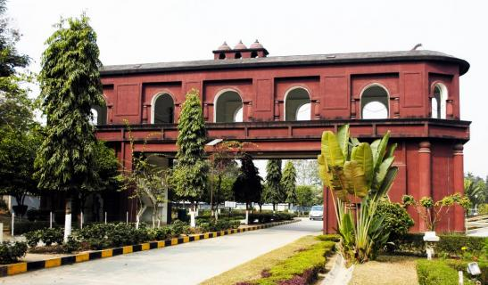
Day 1: Meet our representative at Guwahati Railway station/Airport after arriving in the morning and drive for the full day city tour- State museum, Science museum, Srimanta Sankardev kalakhetra, Balaji temple, Nabagraha Temple, Digholi pukhuri, Planetarium, Assam state zoo. Check in hotel and overnight stay.
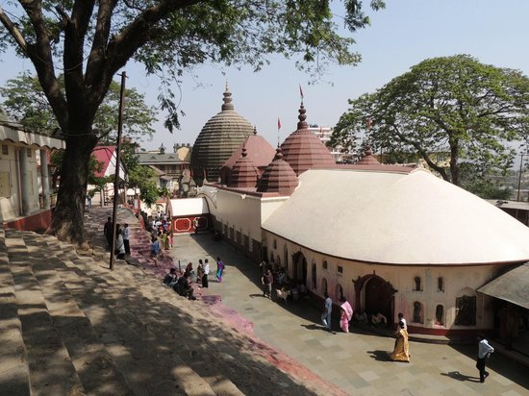
Day 2: Start the journey of the day with visiting Maa Kamakhya Temple early in the morning. After that go to the smallest river island known as ‘Peacock Island’ which have the Umananda Temple. It has also the endangered species of golden langur. Back to the hotel and overnight stay.
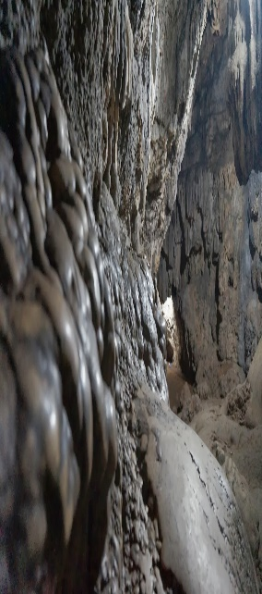
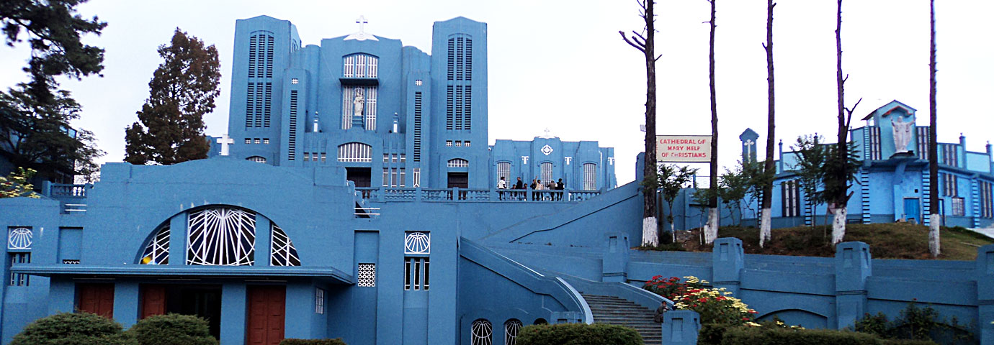
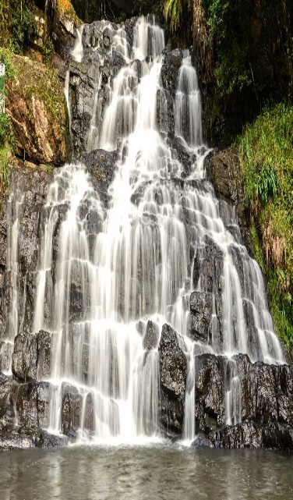
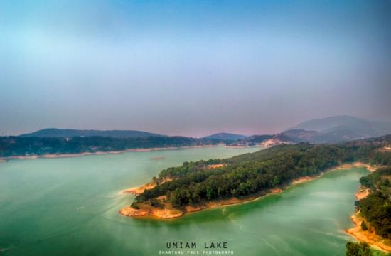
Day 3: After breakfast drive to the Shillong-Scotland of the east en-route visit the Umiam lake-Barapani (the biggest manmade lake of North-East). Check in hotel. After refreshment go for the half day city tour- Wards lake, Cathedral Catholic Church, Shillong peak, Elephant falls, Lady Hydari Park, Latium canyon. Overnight stay at hotel.
Day 4: After breakfast transfer to Cherrapunjee-the wettest place on the earth. Enjoy the full day trip visiting Seven sister falls, Nohkalikai Falls, Masmai cave, Limestone cave, Thankarang park, Double decker root bridge. Back to Shillong and night stay at hotel.

Day 5: After breakfast early in the morning drive to Mawlynong (Asia’s cleanest village) and Dawki (Indo-Bangladesh border). Back to hotel and overnight stay.
Day 6: Check out hotel early and transfer to Guwahati railway station/airport for the final journey.

